In order to grow in this area, I need to…
Stop | Start | 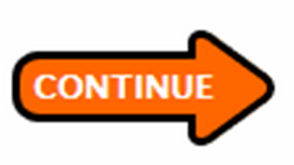 Continue

How will I know if I have made progress in this area? What would be the evidence of growth?

1.

2.

3.

